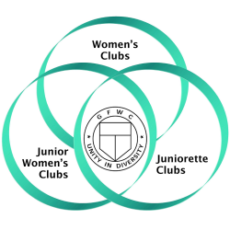
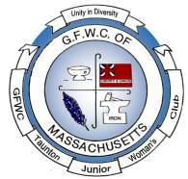
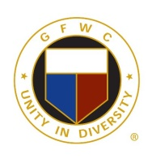
Juniors in Action
GFWC of Taunton and Raynham Juniors
A member of the General Federation of Women’s Clubs
Volume 16 wwwGFWCTauntonRaynhamJuniors.org December 2019
Our Board Members
Edith Edlund – President, Robin Gendron - Vice President, Cindy Brogan - Recording Secretary,
Joanna Alden - Corresponding Secretary, Nancy Clark – Treasurer,
Nancy Martin - Auditor, Cindy Leonard – Director
Highlights of the November Meeting:
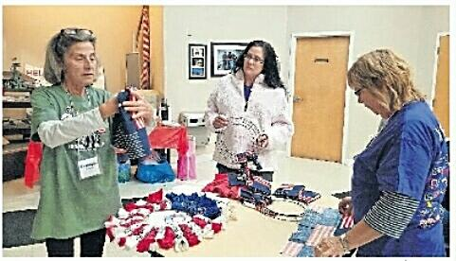
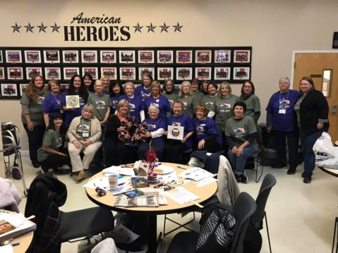
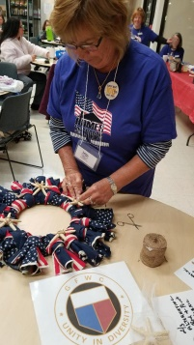
Kathy Sampson gave instructions on how to make a patriotic bandana wreath for our GFWC women’s club Patriotic Project for Home for Our Troops. While working on the wreaths members were invited to partake in refreshments. Upon completion of the wreaths there was a group photo taken of staff members from Home for Troops and club members holding the wreaths. Members wore their t-shirts donated to them from the Director of Home for our Troops. One wreath was left at the center for them to display to Staff Sgt. Paul William Saben Sr. U.S. Army.
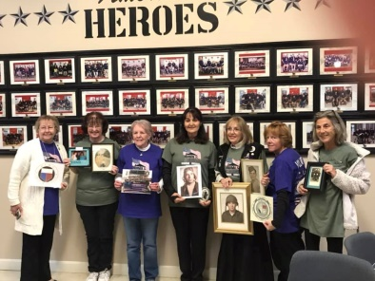
Members also brought in photos of family members who are veterans to share and honor. Members held up each photo and introduced her relative and told a little bit about them.
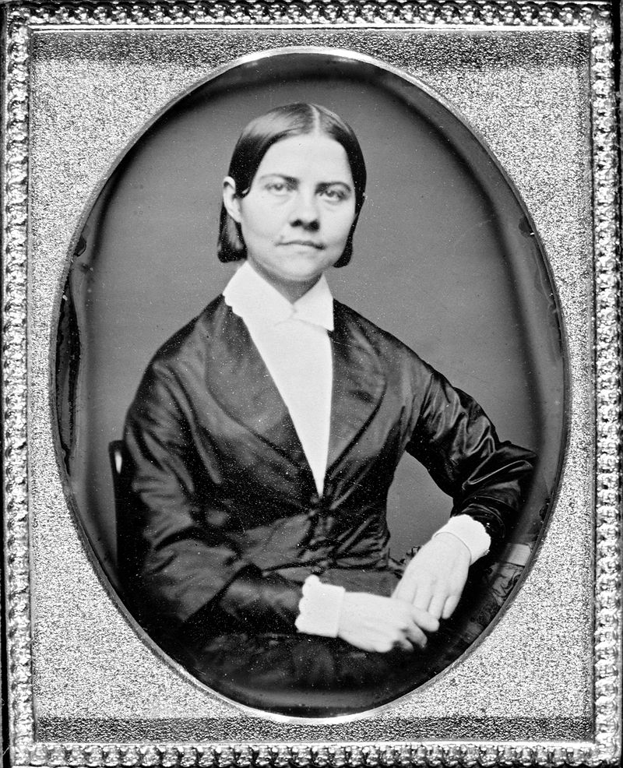
GFWC member Nancy Brown read a biography on Lucy Stone, who was an orator and supporter of women’s suffrage. She was a vocal advocate and organizer promoting rights for women. Stone became the first woman from Massachusetts to earn a college degree. She spoke out for women's rights and against slavery at a time when women were discouraged and prevented from public speaking. Stone was known for using her birth name after marriage, when the custom was for women to take their husband's surname. Stone helped initiate the first National Women's Rights Convention in Worcester, Massachusetts and supported and sustained it annually, along with a number of other local, state and regional activist conventions. Stone spoke in front of a number of legislative bodies to promote laws giving more rights to women. She assisted in establishing the Woman's National Loyal League to help pass the Thirteenth Amendment and thereby abolish slavery. She helped form the American Woman Suffrage Association (AWSA), which built support for a woman suffrage Constitutional Amendment by winning woman suffrage at the state and local levels. Stone wrote extensively about a wide range of women's rights, publishing and distributing speeches by herself and others, and convention proceedings. In the Woman's Journal, a weekly periodical that she founded and promoted, Stone aired both her own and differing views about women's rights. Stone influenced Susan B. Anthony to take up the cause of women's suffrage.
What did our club members do this month?
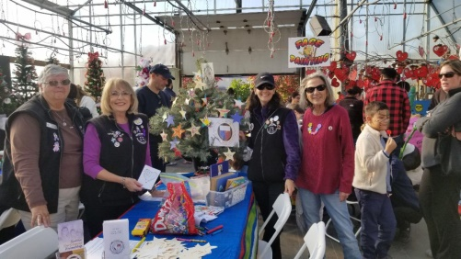
GFWC Taunton and Raynham Jr. Woman's Club participated in the Lion's Club Dighton Art Festival event at Araujo's Farm and Greenhouses. Children were invited to decorate a star ornament and attach it to an evergreen tree to be donated to Homes for Troops and dedicated to all veterans for Christmas. Patrons could also sign Christmas cards which will be distributed to veterans.
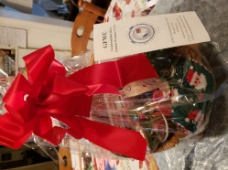
On Saturday, November 23rd, the Berkeley Community School held its” annual PTO Fair from 10--3. Our club donated a beautiful Christmas themed basket for their raffle table. This event is always well attended.
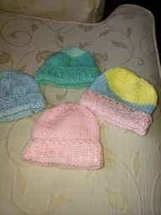
On Wednesday November 13th members Nancy Martin, Joyce Clark and Robin Gendron GFWC State Board members attended the yearly Christmas party. We were reminded that since the combined GFWC conference is being held at Stoneforge Restaurant in January we are assisting with the event and going to be making towel characters among other things for the conference. The theme for the convention is “Cruising to Fall Membership”.
Joyce Clark once again with other members of the club have knitted baby hats and donated them to o Brockton Hospital.
Members Joyce Cark, Cindy Brogan, Edith Edlund and Robin Gendron, along with Cindy’s daughter Kelly and Joyce’s son Brad and her daughter Diana attended the BINGO Designer Purse Bash FUNRaiser for the American Heart Association in Braintree on November 7th. Cindy won a Coach purse worth $398, Kelly won a Coach wristlet and Joyce won a Coach bag.
Nancy Clark reminded members to email or call their legislators on November 23rd, 8 members notified Nancy they Took Action to support the 3D Printed Gun Safety Act.
Nancy Brown delivered three sets of dishes, pots and pans and sheets to the Taunton Family Center. Please continue to bring new and old sheets to be donated.
Nancy Brown delivered Beanie Babies to Prime Time along with tissues, crackers, cookies and puzzles. Please continue to bring these types of items to meetings to be donated.
Joyce Clark bought with club money and delivered in the rain 2 turkeys, 3 boxes of stuffing, 3 cans of cranberry sauce and 3 jars of turkey gravy to St. Vincent DePaul in Taunton. Thankfully two men that were at the center carried the food in for her.
Nancy Brown, Robin and Erica Gendron attended the Mansion tour at Borderland in So. Easton. To enhance our awareness of Women’s Rights the tour emphasized Oakes and Blanche Ames: Women's Right to Vote.
Joyce Clark made a visit a to the Prison Book Program in Brockton on November 21st to deliver 8 Almanacs and 1 Thesaurus, as well as work the night volunteering wrapping books. She is willing to drive members with her on most Tuesdays and Thursdays. Our club has supported this program for many years.
November Newsletter Corrections: both the basket and the earrings were donated by the club NOT Joyce and Denise and Its’ Old Colony History Museum and not the Liberty and Union History Museum.
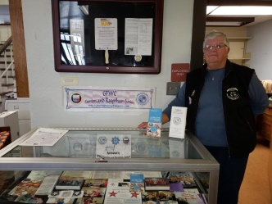
Joyce Clark as Membership Chairman designed a display at the Taunton Library to demonstrate the good our club brings to our communities.
Committees:
ADVOCATES FOR CHILDREN: - Nora Orfanello & Robin Broberg- Nothing at this time.
ARTS - Kathy Sampson–The GFWC Arts Junior Challenge is “What called our ancestors to America?” The reasons are different yet we all come from somewhere else. Tell your story through art, glass, fabric, song or video. More Details are on the website Due at April Conference.
COMMUNICATIONS & PUBLIC RELATIONS - Nancy Brown – Continue to save newspaper clippings and bring them to the meetings. We have been receiving a lot of club publicity online, take some time to check it out.
CONSERVATION – Denise Wheeler Collecting newspapers, puzzles, board games, empty ink cartridges, fabric, yarn, old cell phones, eye and reading glasses, small jewelry boxes, coffee cans, old batteries, embroidery floss, used eye glasses with cases, metal and plastic coat hangers, holiday cards and soda tabs. From GFWC State Board: If your club hosts a Repair Café you could earn extra
points on your year-end report. Contact Laurie for more information. Also, they suggested recycling wrapping paper and bags this Holiday Season.
DOMESTIC VIOLENCE: - Nancy Martin/Joyce Clark- White ribbon campaign will continue in January.
EDUCATION – Nancy Martin/Joyce Clark –We are once again collecting children books for Citizens for Citizens, bring them to the Christmas Business Meeting or Party in December. A reminder there are scholarships for members and their children and grandchildren can apply for. I will bring information about them to the December meeting. You can go on the state site and get additional information yourself. The next Virtual Book Club selection is “Wide Sargasso” A Novel by Jean Rhys, updates will be posted on Facebook. GFWC Mass State will be having a silent on-line auction to raise money for scholarships in the new year.
FUNDRAISING – Cindy Brogan – Once again we are having a Lottery Ticket Raffle, first prize a choice of a book of$2 scratch tickets, 300 tickets worth $600 or $500 in cash, second prize $200 and third prize $100. The tickets sell for $10 each, if a person purchases two they get a third free.
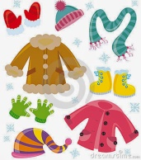
HOME LIFE – Nancy Brown- Prime Time wish list: Individually wrapped snack size; raisins, cookies, chips and crackers. Please note that they now have someone with sensitivity to peanuts. Denise Wheeler is looking for winter hats, gloves, coats, scarfs and earmuffs. She also is looking for twin sheets, blankets, hand towels, etc.
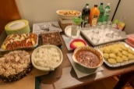
HOSPITALITY – Robin Gendron – Cathy Voller and Cheryl Carlos
INTERNATIONAL OUTREACH –Cindy Brogan- Cindy suggested that at the end of year donation form we donate $100 to both Shot of Life and Heifer. The International Institute of New England is a great resource– check out Suitcase Stories® is a traveling live performance series that features foreign and U.S.-born residents sharing refugee and immigrant stories. The format of storytelling in a theatrical setting and is especially suited to these powerful tales of real-life experience. Check it out https://iine.org/suitcase.
LEADERSHIP: - Paula Gasparoni and Joan Curran – GFWC of Massachusetts Juniors adapted two Amendments at the December Meeting. The information will be shred at the meeting.
MEMBERSHIP ––Joyce Clark / Jane Pacheco– Membership Dues are due $30. Bring to the Business Meeting on Monday.
NEWSLETTER – Nancy Martin – If you do something representing our club during any given month, please forward information about it along with pictures to MRMartin947@aol.com. since there has been little interest of members submitting items to sell, we are discontinuing this from the newsletter.
PRESIDENTS SPECIAL POJECT: Edie Edlund- Has been completed for the year.
PROGRAMS- Joanna Alden –We will have a visit by “Heroes at Both Ends of the Leash”, where veterans and dogs train together sometime in the future.
PUBLIC ISSUES –Cindy Brogan –GFWC Mass Board: If you club would like to support a military family for Christmas, Go to GFWC MA Website Information Please Tab -Project New Hope.
LEGISLATION/ PUBLIC POLICY- Nancy Clark – Click on the picture of the US capital on the slide show on the Home Page of or club's website and 'Take Action' on any of the issues you haven't already addressed
WEBMASTER – Nancy Clark – If you haven't gone to our website yet, go and check it out!
WHRC – Nancy Brown- For Decembers’ Who’s Who Nancy Brown will highlight Blanche Ames who has made a difference in women’s history. WHO'S WHO? A reminder for everyone to please bring their short bio written on an index card to the December meeting. Something about yourself that no one knows that you would like to share. ie: I love to roller skate and was once a member of a skating group or I am a grandmother to 10 boys! Etc.
YEARBOOK–Edith Edlund– If you haven’t received a book, let Joyce Clark know.

Thinking of Members: Send Cards! Robin Gendron
Happy Birthday to Members:
Darlene Brown Brenda Saben Robin Broberg Cindy Leonard
Joyce Clark Nancy Clark Susan Carlson

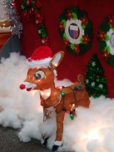
Up Coming Events
Executive Board Meeting at BP on Monday Novembr 25th at 6:00pm
Business Meeting Monday Deember 2nd at BP at 7:00pm
Lights On December 7th starting at 4pm
Membership Chistmas Party at Homeplate Monday December 9th at 5:00pm
Report Writing Meeting TBA
January 25th a GFWC Massachusetts Combined Conference at Stoneforge in Raynham

What Do I Need to Bring to the Meeting?
A check or cash of $30 for Membership Dues
Folded Books
Children Books for Citizens for Citizens
Something for Primetime
Baby Blankets
Recycle Items
Merry Christmas to You and Your Families
From your editor
Nancy L. Martin
Calling all Elves!
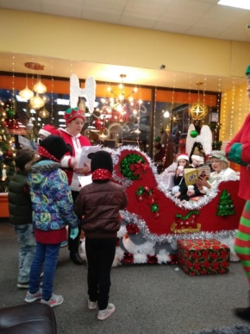
Lights on Saturday December 7th from 4:00 to 8:00 p.m.
Story time with Mrs. Claus and Santa's Elves is on schedule for our club
at Hometown Furnishing on Main Street in Taunton.
Ladies we need you!
Last years the lineup was Edie Edlund, Cindy Brogan, Brenda Saben, Cheryl Costa, Robin Gendron, Nancy Martin, Nancy Clark and Fran Perry
Don't be shy!
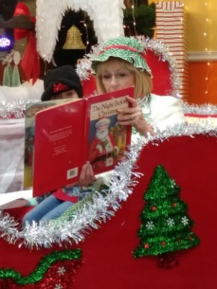
New members please sign up on Monday night and join the ranks
Requirements are to dress up like an elf:
Stocking hats, elf ears, elf shoes, jingle bells, tights, red, white and green.
This year's theme is 'The Night Before Christmas"
So you may want to dress as Mama in her kerchief or papa in his cap
Remember that this is our clubs holiday community project to spread good will and cheer to Let everyone know who the GFWC of Taunton Juniors are and what we do
Nancy Brown will be dressed as Mrs. Claus to read to the children while Santa's elves
greet them, distribute cookies and letters to Santa
If you can give an hour or two or the whole night call Nancy Brown at 774 218-1456

Publicity Articles 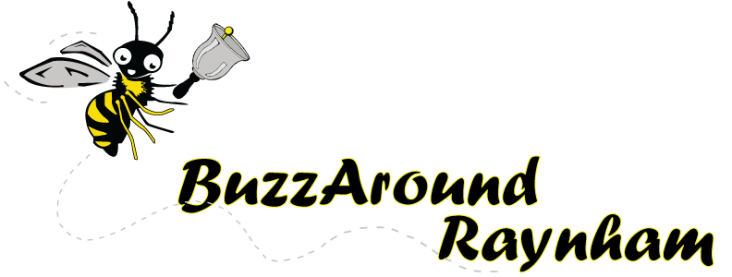
GFWC Taunton and Raynham Jr. Woman's Club participated in the Lion's Club Dighton Art Festival event at Araujo's Farm and Greenhouses. Children were invited to decorate a star ornament and attach it to an evergreen tree to be donated to Homes for Troops and dedicated to all veterans for Christmas. Patrons could also sign Christmas cards which will be distributed to veterans.
Photo & Story Credits: Nancy Brown

GFWC Taunton and Raynham Jr. Women’s Club to host reading with Mrs. Claus
The GFWC Taunton and Raynham Jr. Women’s Club will host a reading with Mrs. Claus and Santa’s elves at the Lights On Celebration from 4 to 8 p.m. Dec. 7 at Hometown Furnishings, 49 Main St., Taunton.
Children can join Mrs. Claus and Santa’s elves to hear a reading of “The Night Before Christmas” and have their picture taken with Mrs. Claus.
Santa’s elves will be handing out holiday sugar cookies and letters to send to Santa in time for Christmas.
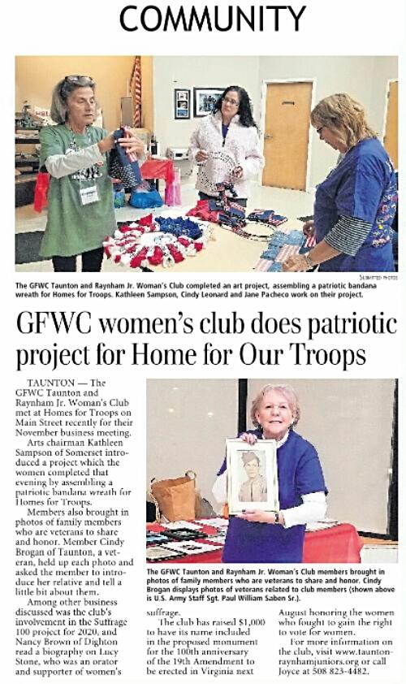
Lights On buttons are for sale at several locations throughout the city and are necessary to gain entrance to visit Mrs. Claus.

