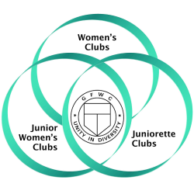
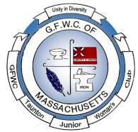
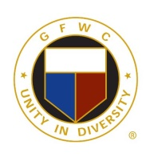
Juniors in Action
GFWC of Taunton and Raynham Juniors
A member of the General Federation of Women’s Clubs
Volume 15 wwwGFWCTauntonRaynhamJuniors.org November 2019
Our Board Members
Edith Edlund – President, Robin Gendron - Vice President, Cindy Brogan - Recording Secretary,
Joanna Alden - Corresponding Secretary, Nancy Clark – Treasurer,
Nancy Martin - Auditor, Cindy Leonard – Director
Nancy Martin – Newsletter Editor: MRMartin947@aol.com

Highlights of the October Meeting:

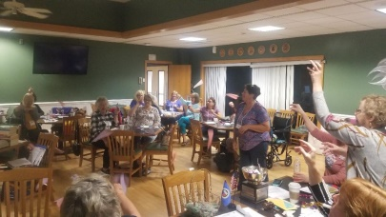
During the meeting Nancy Martin conducted a fun activity to celebrate Domestic Violence and cancer month. Purple and pink printing paper was passed out to members who were asked to write something about themselves they would like to share that members might not be aware, they could be fun things, cancer related or domestic violence in nature. Nancy then led the members with instructions on how to turn their papers into paper airplanes step by step with a demonstration. Then everyone was asked to close their eyes and throw their planes. Then everyone was instructed to pick up a plane. Members were to guess who wrote the message on their plane they picked up, some members read their messages out loud and guessed along with the membership who wrote the tidbit about themselves.
Cindy Brogan and her committee reminded everyone about the winter fundraiser. She distributed additional raffle tickets to sell to members who needed more or had not received any. The prizes are the following: first prize is a choice of a book of $2 scratch tickets worth $600 or $500 in cash, second prize $300 and third prize $100. The tickets sell for $10 each, if a person purchases two they get a third free.
The By-Laws Committee chaired by Cindy Brogan recommended two changes in the By-Laws and presented them at the September Business meeting. A copy of the changes was sent to those that were absent. During this month’s meeting members voted their approval of the By-Laws. Our next GFWC Junior By-Law changes will reflect those approved at the Annual Convention. Changes to the names of the program areas. This will not go into effect until 7/1/2020. Our by-laws will need to reflect the newly titled programs.
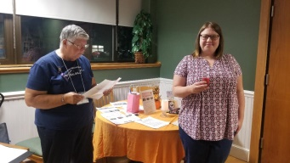
The GFWC Taunton and Raynham Junior Woman's Club added to their numbers on Monday night with the installation of Emilie Weiland from Rehoboth, Massachusetts. The new member was installed by Membership Chairman Joyce Clark.
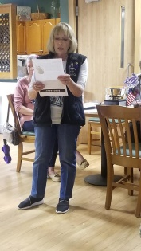
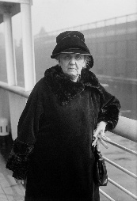
Nancy Brown highlighted Jane Addams as the WHRC Woman of the month who won the Nobel Peace Prize in 1931. Her role was as an International President of the Women's International League for Peace and Freedom. Jane Addams was the second woman to receive the Peace Prize. She founded the Women's International League for Peace and Freedom in 1919, and worked for many years to get the great powers to disarm and conclude peace agreements. In the USA she worked to help the poor and to stop the use of children as industrial laborers. She ran Hull House in Chicago, a center which helped immigrants. During World War I, she chaired a women's conference for peace held in the Hague in the Netherlands, and tried in vain to get President Woodrow Wilson of the USA to mediate peace between the warring countries. When the USA entered the war instead, Jane Addams spoke out loudly against this. She was consequently stamped a dangerous radical and a danger to US security. Addams was critical of the peace treaty that was forced on Germany in 1919, maintaining that it was so humiliating that it would lead to a German war of revenge. At the end of her life, Jane Addams was honored by the American government for her efforts for peace.
Conservation Chairman, Denise Wheeler reminded everyone how to make picture and notecard holders, by folding each page of a paperback book and gluing the sides together. She gave out books that would work well to make them to members who showed interest in making them for the club over the next month. She said she would complete the covers all you had to do was fold. Several members took books.
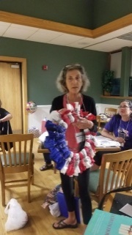
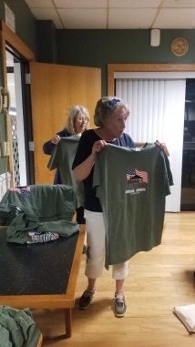
Cindy Brogan Public Issues Chairman gave out shirts donated by “Homes for Our Troops” to members to be worn to the November meeting being held at their location on Main Street in Taunton. We received a thank you letter from Homes for Our Troops for our $100 donation.
Kathy Sampson Arts Chairman showed members a wreath she made with red, white and blue bandanas for Veterans Day. This will be our club project for November. We will leave one with the Homes for Our Troops for talking and sharing their home with us. A few club members donated material, specifically Joan Curran, and Kathy who then shared pieces with members to cut and prepare for the meeting. She is looking for members to bring patriotic ribbons and ornaments to decorate the wreaths to the November meeting. She will them deliverer them to veteran organizations.
Nancy Clark Chairman of Legislation and Public Policy said 8 members had responded to support the “Mianda’s Law” on October 23rd. She also reminded members to continue to support the GFWC efforts and Take Action when asked to do so and inform her if you do.
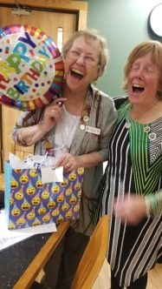
President, Edie Edlund read a letter that explained that she would be resigning as President of our club as of December 31, 2019 due to health issues. The membership gave her a standing ovation to show our appreciation of the great job she has done as our president. This was followed by a discussion on the process that should be followed to fill the vacancy. Cindy Leonard, Club Director was given the directive to call the membership and findanyone interested in the position. Robin Gendron Vice President has shown a desire to fulfill the position, leaving her position open.
Joyce Clark Membership Chairman gave out gifts for members whose birthdays were in October. We had a cake and sang to our Club President who was celebrating her 70th birthday. Happy Birthday Edie!
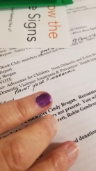
Cindy Brogan requested that we continue our support of the past Presidents’ Project “Wild Hearts Horses for Hero’s with a $100 check, and it was approved unanimously.
Joyce Clark as Domestic Violence and Prevention Chairman brought purple nail polish and asked members to paint their baby finger nails purple and wear it proudly to represent Domestic Violence Month.
What did our club do this month?
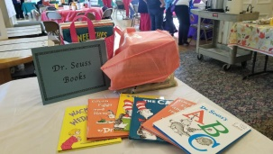
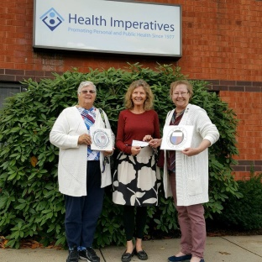
Robin Broberg reached out to the Director of Penelope’s Place in Brockton and with assistance from Edith assisted in the completion of the grant from the GFWC of Massachusetts for money to make the repair to a broken window. They were awarded a grant for $300 from the GFWC of Massachusetts at the conference. On Wednesday 0ctober 30th Edie Edlund and Joyce Clark presented the check to the Director of Health Imperatives the head office for Penelope’s Place. She also reminded everyone that November 17th is “World Premature Day.” This brought about a discussion of how many in the club or family members have had premature babies. A few members shared stories of what they endured or observed. Joyce Clark knitted over 40 newborn hats and delivered them along with Edie Edlund on Wednesday October 30th to Brockton Hospital maternity ward. Robin also asked that members bring baby blankets to the next meeting.
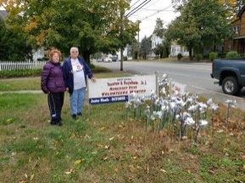
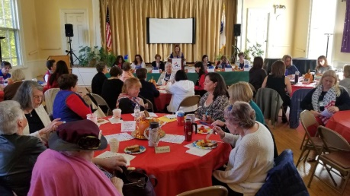
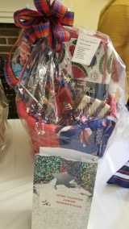
Nancy Martin Education chairman shared information to Martin School Principal Mrs. Rodrigues about a middle school in El Paso looking for students from another state to share some positive words with their students after their tragedy for approval. It was granted and member Denise Wheeler, a teacher at Martin School offered to do this with her students. Postcards and stamps were bought through our club to support this endeavor.
Joyce Clark Chairman of Domestic Violence Awareness and Prevention and Robin Gendron once again took the time and energy to display our purple pinwheels with our club poster on a Winthrop Street residence lawn to help bring awareness of this noteworthy project to the citizens in the Taunton area.
Joyce Clark as Membership Chairman also took time to put displays at local libraries to demonstrate the good our club brings to our communities. This is for Membership Drive Month in hopes to get new members. Talk up our club to friends and people you meet at worthy events.
Fran Perry has been contacting members to purchase dine out books again. The money raised is going to be donated to veteran affairs.
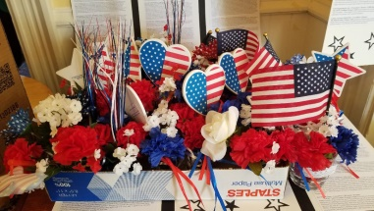
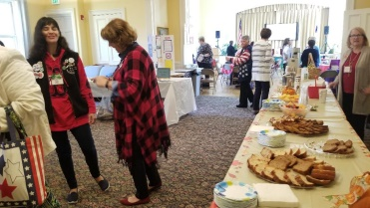
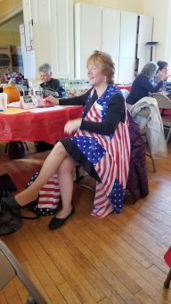
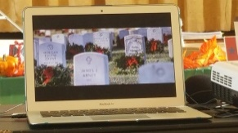
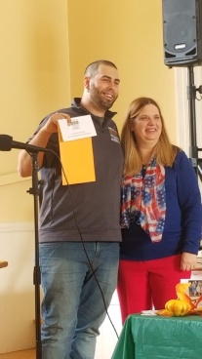
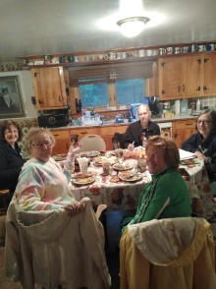
Seven club members attended the GFWC of Massachusetts Junior Membership Conference in Dedham at the Allin Congregational Church on Saturday October 26th. They were Nancy Martin, Denise Wheeler, Nancy Clark, Cindy Brogan, Joyce Clark, Robin Gendron, and Nancy Brown. The theme was Patriotism, which members could show by wearing red, white and blue attire. Our club donated 8 Dr. Seuss books, 16 shoes for Soles for Souls, 5 bottles of wine and a check for $150 for Wreaths Across America and a patriotic basket for the raffle put together by member Joyce Clark which help to raise $605. Club member Nancy Brown won a Photography Award. We participated in a Service Project by creating 70 red, white and blue flower arrangements to be donated to the German Center in Dedham. There were two speakers the first was Kelly Hinkle from “Wreaths Across America” introduced by our member Cindy Brogan. He talked about how it was started by one person named Kelly who owned a floral business and wanted to do something with extra wreaths he had to what now services 2000 locations including Arlington cemetery in Virginia. He talked how families who have lost someone in action for our country can request a free golden star tree with special dog tags placed on the golden tree which gets tipped every three years to make the wreaths from. He also explained step by step how the process from the request of a tree to the placement of the wreath on a veteran’s grave takes place. He shared stories of pictures being taken for a family of the placing of the dog tag on a golden tree and the placing of a wreath on a veteran’s grave was sent to the serviceman’s family for those who cannot attend the ceremony in person. Our club donated $150 to the program which was part of the $2000 donated by the GFWC of Massachusetts Juniors. Amy Schram BBB Manager Community Relations shared many ideas on how to stay safe with phone scammers, email threats, and online security. It is a 52 billion dollar industry of identity theft scammers. The Imposter Scam– they contact us and miss represent themselves as other agencies to capture your information. Phishing scams– are very dangerous– they look official. They are embed links that attach to your computer and it now becomes an open door to thieves. Amy shared resources and free services with those present at the conference. A game of Heads and Tails played with beads was run by the Education Chairman as a 50/50 raffle that raised $122.
A Fashion Show Committee Meeting was held on Sunday, October 27 at Mary Barrett’s house. Committee members are Mary Barrett co-chair, Edie Edlund co-chair, Robin Gendron, Judy Ackerman, Suzanne Kaye and Sarah Brink.

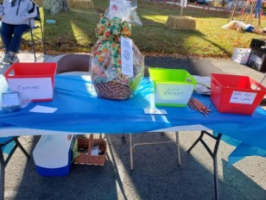
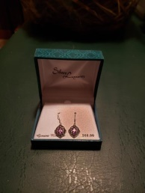
The Liberty and Union Celebration was an exciting and fun event once again which surpassed last year's celebration. Mother Nature even cooperated with a picture perfect day! Many more vendors, reenactors, food stands, dancers, colonial dancing, period fifers, face painting, etc., were in attendance making it an entertaining day for the crowds that came. Our club had a Free Raffle Table that generated much interest, overseen by Mary Barrett in colonial attire. Thanks to Joyce Clark and Denise Wheeler for putting together a beautiful Fall/Thanksgiving Basket and for donating a stunning pair of marcasite earrings valued at $60.00. The drawing was held at 3:30 and the lucky recipients were notified by phone. There were several ladies who were very interested in our club and what we do, one of which took a picture of the club flyer on the gift basket. Perhaps we'll get some new members or visitors at our upcoming meetings! This was orchestrated by our member Mary Barrett whose is a member of the Liberty and Union Historical Society.
Joan Curran and Joyce Clark brought 43 bags of clothes collected through the club to Sudbury on Thursday October 31st for the GFWC of Massachusetts to be sold to Savors as a headquarters fundraiser.
Committees:
ADVOCATES FOR CHILDREN: - Nora Orfanello & Robin Broberg- World Preemie Day is November 17th, bring baby blankets to the next meeting.
ARTS - Kathy Sampson– At this month’s meeting we will be making veteran wreaths with material. We will give one of them to Home for Troops where we are meeting this month. If you have patriotic ornaments or ribbon bring it with you this month. The GFWC Arts Junior Challenge is “What called our ancestors to America?” The reasons are different yet we all come from somewhere else. Tell your story through art, glass, fabric, song or video. More Details are on the website Due at April Conference.
COMMUNICATIONS & PUBLIC RELATIONS - Nancy Brown – Nancy Martin and Nancy Clark will be assisting with the video for “How will you use video in your club promotions?” Communications & PR Challenge “Make your voice heard and jump into video with the 2019/2020 Challenge”, videos
are due February 28 2019. Details are on the website along with a 1 page report sheet.
CONSERVATION – Denise Wheeler Collecting newspapers, puzzles, board games, empty ink cartridges, fabric, yarn, old cell phones, eye and reading glasses, small jewelry boxes, coffee cans, old batteries, embroidery floss, used eye glasses with cases, metal and plastic coat hangers, holiday cards and soda tabs.
DOMESTIC VIOLENCE: - Joyce Clark- If you go by Winthrop Street and see our pinwheels take a picture and share.
EDUCATION – Nancy Martin/Joyce Clark – If you have a new baby in the family, daughter, son, granddaughter, grandson, great-grandmother, or great-grandson, please let us know so we can honor them with a “A Book A Baby Program” by donating a book to your local library in their name. We are once again collecting children books for Citizens for Citizens, bring them to the Christmas Party in December or the November Meeting.
FUNDRAISING – Cindy Brogan – Once again we are having a Lottery Ticket Raffle, first prize a choice of a book $200 scratch tickets worth $600 or $500 in cash, second prize $300 and third prize $100. The tickets sell for $10 each, if a person purchases two they get a third free.
HOME LIFE – Nancy Brown- Prime Time wish list: Individually wrapped snack size; raisins, cookies, chips and crackers. Please note that they now have someone with sensitivity to peanuts. Denise Wheeler is looking for winter hats, gloves, coats, scarfs and earmuffs. She alos is looking for twin sheets, blankets, hand towels, etc.
HOSPITALITY – Robin Gendron –November is yet to be determined.
INTERNATIONAL OUTREACH –Cindy Brogan- Nothing at this time.
LEADERSHIP: - Paula Gasparoni and Joan Curran – Nothing at this time.
MEMBERSHIP ––Jane Pacheco/Joyce Clark – If you go into any of our local libraries and see our membership display, take a picture and share it. GFWC Juniors Challenge is “How do you promote new membership?” Next reporting period is the fall recruitment December 1st. The club with the greatest gain June 1 2019– March of 2020 Details are on the website .
NEWSLETTER – Nancy Martin – If you do something representing our club during any given month, please forward information about it along with pictures to MRMartin947@aol.com. Reminder members can place up to three ads a month in the Newsletter for free. Deadline for submissions is one week before each meeting.
PRESIDENTS SPECIAL POJECT: Edie Edlund- We have reached our goal of $1000.
PROGRAMS- Joanna Alden –We will have a visit by “Heroes at Both Ends of the Leash”, where veterans and dogs train together sometime in the future.
PUBLIC ISSUES –Cindy Brogan –Don’t forget to vote in November! Use your right to vote!
PUBLIC POLICY & LEGISLATION– Nancy Clark –On October 23rd GFWC members were asked to call or email your Representative and Senators on the 3D Printed Gun Safety Act and let Nancy clark know if you did.
WEBMASTER – Nancy Clark – If you haven’t gone on the site yet, check it out and make any suggestions for updates!
WHRC – Nancy Brown- Next month she will highlight a woman who has made a difference in history. She is also looking into assisting the city with its celebration of the 19th Amendment.
YEARBOOK– Mary Barrett– If you haven’t received a book, let Joyce Clark know.

Happy Birthday to Members:
Robin Gendron Paula Gasparoni

Thinking of Members: Send Cards!
Joanna Alden is still under the weather
Vel Bleau’s husband passed away

Up Coming Events
Business Meeting at Homes for Troops at 6 Man Street in Taunton on November 4th at 6:00pm
Wear your shirt!
Board meeting November 25th at Bristol Plymouth at 6:30pm
Dighton Arts Festival November 3rd, 9:00am to 3:00pm
BINGO Designer Purse Bash, FUNRaiser for the American Heart Association in Braintree on November 7th

What Do I Need to Bring to the Meeting?
Wear Your Homes for Troop Shirt
A picture of someone in your family that is a veteran in uniform
Red, white and blue ornaments and ribbon
Folded Books
Children Books for Citizens for Citizens
Something for Primetime
Baby Blankets
Recycle Items

“Every star in this universe represents the soul of a soldier who gave their life for the life you live today, so make sure that you thank any Veteran you see”

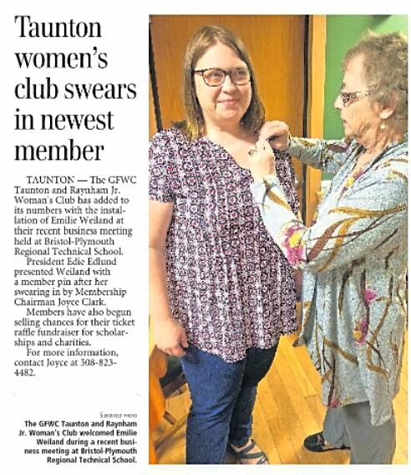
Publicity Article

