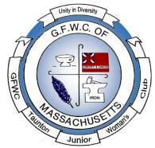
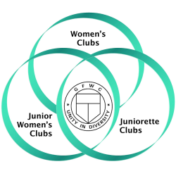
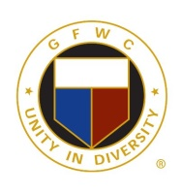
Juniors in
Action
GFWC of Taunton and Raynham Juniors
A member of the General Federation of Women’s Clubs
Representing: Taunton, Bridgewater, Dighton, Assonet, Raynham, Norton, Berkley, Brockton, Somerset, Freetown &Rehoboth
Volume 37 wwwGFWCTauntonRaynhamJuniors.org November 2022
President – Robin Gendron, Vice President –Emily Weiland, Recording Secretary - Joyce Clark,
Corresponding Secretary - Judy Ackerman, Treasurer –Sarah Brink, Auditor –Cindy Brogan,
Director – Nancy Martin
October Meeting:
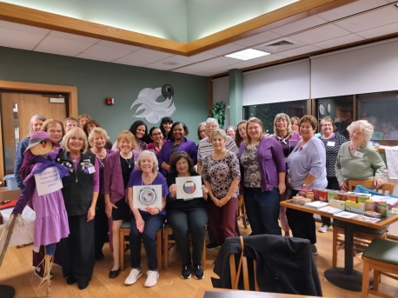
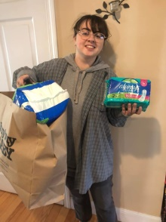
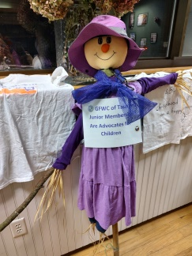
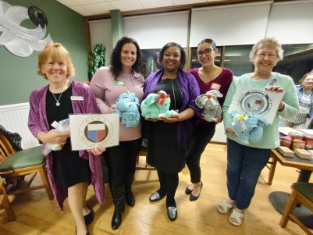
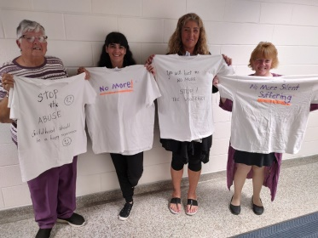
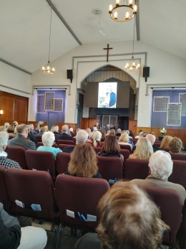
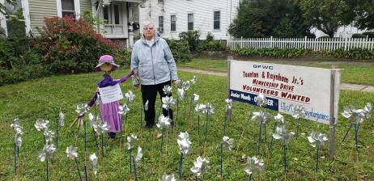
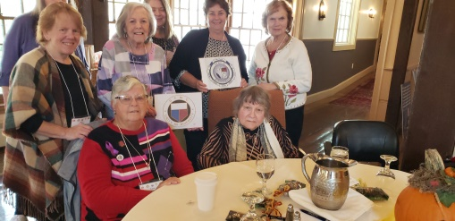
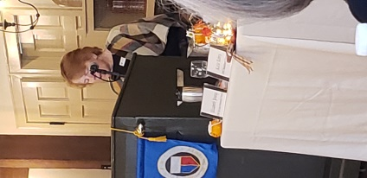
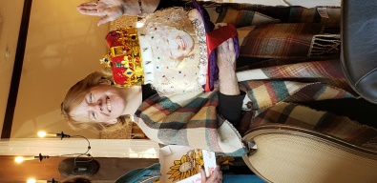
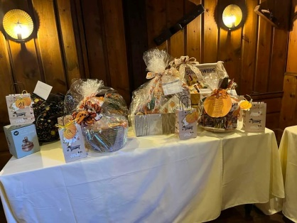
The Program was a group of ladies including Kyra Fernandes and April George from the Taunton Diversity Network, Inc., TDN. Their goal is to fulfill the will of the people and to empower them with positivity. They support “Period Poverty Supply Campaign” and are in partnership with “New Hope”. They support politicians that support their views, they are bipartisan. They attend City Council Meetings inspiring change in the city of Taunton. They host community events, Domestic Violence Vigils, one occurring October 20th at the Church Green, Community Clean Up, Voter Education, and Civic Engagement events. Our club donated the elephants our club members contributed towards and made under the guidance of member Edie Edlund, which included a towel, face cloth, and feminine hygiene products along with a check for $100. Member Anna Kearnans’ family has donated to the “Period of Poverty” with feminine products and would like members to join her with contributions for the months of November and December. Members were encouraged to wear purple to the meeting. Our shirts made in previous years and new Scarecrow was displayed during the meeting to bring Domestic Violence Awareness to the membership. We had 76% attendance; we contribute that to the good leadership of our board. Members were encouraged by the Education Chairman to vote for the Prison Book Title. Health and Wellness Chairman talked about Breast Cancer and encouraged members to check ones self each month and the proper way to do it. Public Policy & Legislation Chairman: talked on Call to Action Update and gave out a sheet of ways to gain points for our club by taking certain pictures and posting on social media. If you haven’t been receiving notices of new topics to send to your legislatures sign up once again to “Call for Action”. Robin Gendron and Joyce Clark collected and brought to Sudbury 14 bags of clothes to the GFWC Mass Junior Membership Savor fundraiser. Several members attended our President Robin Gendron fathers’ wake and funeral as well as Honorary Member Thelma McCaffreys’ memorial mass. Both Robin Gendron and Thelma McCaffreys’ families thank the membership for their support at their difficult time. Nancy Martin read a tribute to Thelma mentioning her dedication to our club along with a few funny stories. Joyce Clark, her husband and Nancy Martin displayed our pinwheels, sign and scarecrow in support of “Advocates for Children Month” and the fight Against Domestic Violence. The rent relief for October was won by Nancy Brown, who will be providing Novembers’ prize. A total of $47 was raised. A reimbursement of $78 should be received soon from Compass Self Storage. Thank you everyone for helping each month with our rental fee for our new storage unit. Denise and Robin successfully transferred everything from the Chandler Avenue storage to the UHaul Facility on Winthrop Street/Warner Boulevard in Taunton. The cost of the unit has doubled so our contribution through the monthly drawings is even more needed. The Program for the November 7th meeting will be guest speaker Sheila Bouchard, from “Designs by Sheila”. She will instruct members on floral designs and creations of fall arrangements which can be transformed into winter arrangements for the holidays. Fifty tins were donated by our club member Edith Edlund to local artist Rose, who painted on them beautiful flowers, ribbons, etc. and returned them to us through member Emily Weiland. The Executive Board made the decision to save them until Valentines’ Week and fill them with candy and cookies then deliver them to veterans or nursing homes, if any member has more suggestions please share them at the meeting. Emily would like to thank the Sugar Mamas for the 22 pounds of sugar that was collected at the October meeting. Our club was represented by two members at the Diversity Walk on the Green; Ana Kearnan and Robin Gendron. Our club was recognized in a shout out as supporters of TDN. The Executive Board voted to donate $50 to St Vincent DePaul in President Robins Gendrons’ fathers’ name. Denise Wheeler and Robin Gendron collected bags of clothes from our storage unit and donated them to the Knights of Columbus. During the November meeting we will be taking pictures with our club aprons to put on our Webpage and Facebook page to reach nonprofit organizations letting them know we are available to assist with fundraising events. The Christmas Party will be at the Fireside Restaurant in Middleboro on Monday December 12th from 6 to 9. It will be a buffet cost is $40 for nonmembers, $20 for members. The Christmas Party committee will be making a presentation about the event at the November meeting. Combined GFWC of Massachusetts and Junior Membership Fall Conference was attended by 8 members: Robin Gendron, Cindy Brogan, Joyce Clark, Nancy Clark, Grace Doel, Edith Edlund, Nancy Martin, Emily Weiland and Joan Curran. It was at the Publick House in Sturbridge on Saturday October 29th from 9:00am to 3:30pm with 78 attendees. Our President Robin Gendron Leads Graduate made a presentation. Massachusetts Junior membership won several awards due to our club on Special Projects. The focus of the speakers was on Mental Health. There were 3 speakers: Allies for Student Mental Health - Michelle Ward-Gilles, Why Me? - Meg Halvorsen and Wings for Wellness- Serena Charbonneau. Our club brought our decorated pumpkin designed by Nancy Brown and Denise Wheeler and our basket for the state raffle along with 27 other baskets helped to raise $1585. The first one on the left was our contribution. Our club members in attendance won 8 of the 28 baskets. Our club donated 2 gift cards, 57 toiletries, 12 journal, pens, etc., and 4 socks/PJs/underwear. The items helped to make 50 toiletry bags and $360 in gift cards. They are being donated to the Why Me Program and Emergency for Domestic Abuse. A complete report will be given at the November meeting.
COMMITTEES:
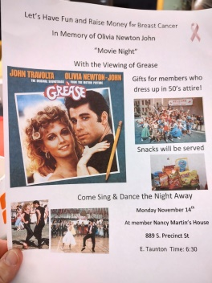
ADVOCATES for CHILDREN–Robin Gendron – Presidents’ Project - Continue to collect trial size personal care products for JRI Foster Care and Adoption Agency.
ARTS AND CULTURE–Edith Edlund – A social event is in the planning: a 50’s night honoring Olivia Newton John and Breast Cancer is in the works for Monday November 14th at 6:30: Nancy Martin’s house 889 S. Precinct St, E. Taunton, $5 donation. Gifts for members dressed in 50’s attire.
CIVIC ENGAGEMENT AND OUTREACH –Cindy Brogan – Items for Thanksgiving baskets: stuffing mix, gravy, cranberry sauce, canned pumpkin, baking mixes & frosting, pickles/olives, canned green beans, cream of mushroom soup, fried onion rings, other canned vegetables
COMMUNICATIONS AND PUBLIC RELATIONS– Judy Floor – If you have pictures and or articles you would like sent to the newspapers, please forward to Judy.
DOMESTIC VIOLENCE AND SEXUAL ASSAULT – AWARENESS AND PREVENTION: - No report
EDUCATION AND LIBRARIES – Nancy Martin – Nov 8th: 5:00pm Prison Book Program (new date!) Contact Emily to join.
ENVIRONMENT – Denise Wheeler – New items: used CDs for classroom art projects. Denise has paper lists of items for recycling that our club collects. Just ask her and you shall receive! The list is also on our website.
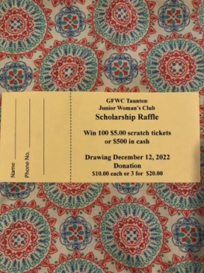
FUNDRAISING AND DEVELOPMENT – Diane Huling – Our club is selling lottery raffle tickets again this year. Cindy Leonard is chairing this fundraiser. Tickets were given out at the September meeting; if you didn’t get any you can get tickets at the October meeting. This fundraiser is to raise money for our educational scholarships. We pull the winner December 12th at our annual Christmas party. You have a choice to get the $500 worth of sealed lottery scratch tickets or the cash. Thank you in advance for your support. Price is one for $10 or three for $20. Plenty of time to sell, sell, sell! New this year, the member who sells the winning ticket will receive $100. We are also planning a Soup and Pie Social on December 10, 2022 at the Winthrop Baptist Church on Winthrop Street in Taunton. There will be a variety of homemade soups and pies for you to sample and enjoy. This has been a huge success in prior years and we hope to see you there. Tickets will be on sale starting on November 8th.
HEALTH AND WELLNESS – Anna Kearnan – Get out and walk! Check your breast monthly for new lumps. Collecting feminine products for “Periods for Poverty” what is it you ask: In spring 2020, as the COVID-19 pandemic began to shut down access to many services some patients became badly in need of menstrual products but could not afford them. A patient was in her late teens and had reached out in a moment of crisis in need of free menstrual pads. Her family did not have money for pads, and she often needed to use toilet paper as a replacement, which was both annoying and embarrassing. She had also become quite dependent on the pads she receives from her school, which was now closed due to the pandemic.
LEADERSHIP – Nancy Martin –Think about joining one of the committees by emailing the chairman with your interest.
LEGISLATION/ PUBLIC POLICY – Nancy Clark – with local and state legislators running for office, it's the perfect time to get a photo with a current legislator and post it on Facebook, Twitter, or Instagram with the "#GFWCadvocacy"/tag. There has been a new legislative alert:. Support Childhood Global Vaccination Efforts. If you have not received this reapply to “Call for Action!”
MEMBERSHIP – Joyce Clark –Three yearbook corrections: Sarah Brink: 508-644-5308, Linda Brosseau: 508-952-2186, Joanna Alden 306 Carver Street. Collecting money for dues: $30, checks should be out to GFWC Taunton Junior Membership.
WOMENS HISTORY AND RESOURCE CENTER– Nancy Brown- No report

Member Birthdays
Robin Gendron Paula Gasparoni

What’s Happening Within our Club?

Dighton Arts Festival November 6th at Araujo’s Farm Nancy Clark will host a table

Nov 7th Business Meeting 7:00pm at Silver Platter B P

Hospitality: Diane Huling, Mary Barrett & Cindy Leonard

Rent relief Gift: Provided by Nancy Brown

Bring a $30 check made out to the club for your Membership Dues

Nov 8th Prison Book Program (new date!) Contact Emily to join

Nov 14th Movie Night / Breast Cancer Fundraiser at Nancy Martin’s house with a viewing of “Grease” at 6:30pm: a $5 entrance fee with proceeds going to Breast Cancer in memory Olivia Newton-John. Wear 50’s attire and receive a gift.

Our next Executive Board Meeting is November 28th at 6:00pm Silver Platter

Soup and Pie Social on December 10, 2022 at the Winthrop Baptist Church on Winthrop Street in Taunton

Club Christmas Party December 12th:Lottery Raffle Ticket winners picked at the party

Homeplate Fundraiser: TBA

What to bring to the meeting November 7th?

Feminine Products for “Period of Poverty”

Food for Thanksgiving Baskets

Dictionaries, thesaurus and newish soft covered books and puzzle books.

Don’t Forget to Vote
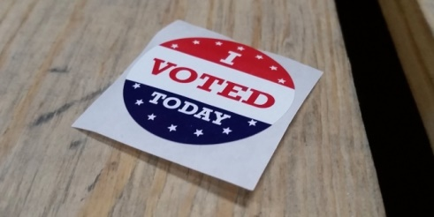

Good Evening GFWC Massachusetts Junior Membership Club Leaders,
We have been hinting about an upcoming fundraiser in Topics and at GFWC MA Fall Meeting, now it’s time for ALL Club Members & friends and family to get ready to help. We are 5 days away from the kick-off of a HundredX online survey fundraiser. Attached is a flyer that gives the highlights, with more information on the GFWCma.org site – go to the GFWC MA Members tab | click on Fundraising. There will be more information and a PowerPoint Presentation about the program.
Please know that this company was well-researched and will never use or sell your information to other companies. The HundredX company will ONLY contact you throughout our 30-day fundraising campaign from November 7th until December 5th. After December 6th all the participants in the GFWC MA campaign will be deleted.
The surveys are quick and easy to fill out and take about a minute or a little more to complete each one. Each person is allowed to fill out up to 75 surveys over the 30-day campaign. Eligibility is to be 18+ years old, live in the US and have an email address. You can use the device of your choice to fill out the surveys, laptop, tablet, iPad, or phone. There are over 2000 nationally known companies to choose to take a survey. It will take approximately 3 hours – however that is over 30 days!
Please share the attached flyer with your club members now and get them prepared to sign up beginning on November 7th (the earliest). The QR code on the flyer can be used or you can text the word IMPACT to 90412, and a link will be sent to your phone.Please reach out with any questions and get ready to help GFWC MA raise funds without you spending a dime!

From Your Editor:
Happy Thanksgiving
