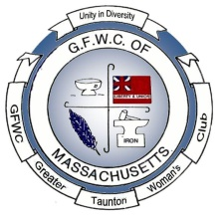
Juniors in
Action
GFWC of Taunton and Raynham Juniors
A member of the General Federation of Women’s Clubs
Representing: Taunton, Dighton, Assonet, Raynham, Norton, Berkley, Brockton, Freetown, Middleboro & Rehoboth
Volume 44 www.gfwcgreatertauntonwomen.org June 2023
President – Robin Gendron, Vice President –Emily Weiland, Recording Secretary - Joyce Clark,
Corresponding Secretary – Ana Kearnan, Treasurer –Sarah Brink, Auditor –Cindy Brogan,
Director – Nancy Martin
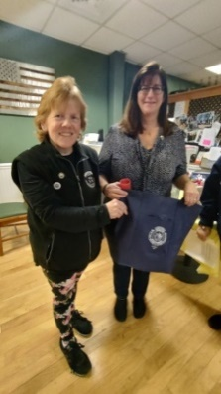
May Business Meeting:
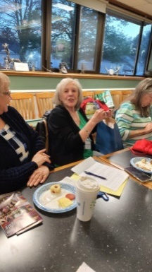
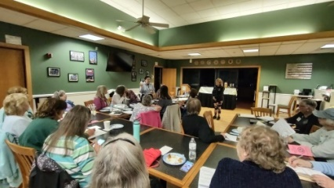
There was an installation of a new member Jennifer Rego. Introduce yourself to her when you get a chance. Member Ana Kearnan gave a talk on protecting your skin during the summer by explaining good skin care. Suggestions were: check sunscreen expiration date, use lip-gloss with sunscreen, and apply the sunscreen 15 minutes prior to going outside. Our new aprons have arrived. We now have blue and red aprons along with our club shirts to wear to events thanks to Cindy Brogan and Nancy Brown.
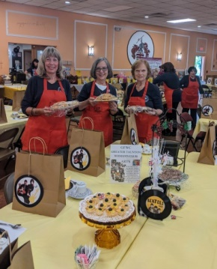
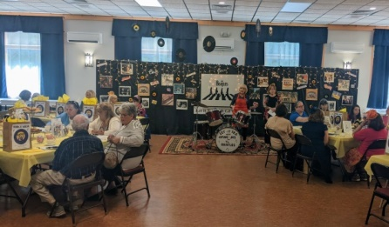
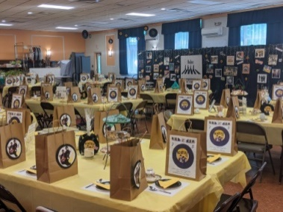
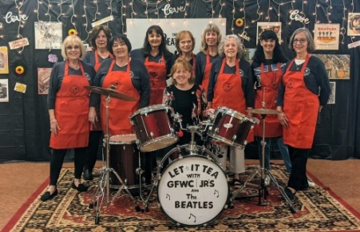
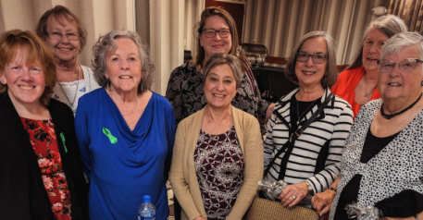
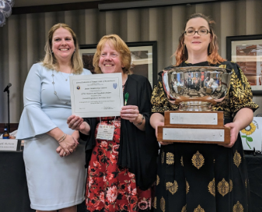
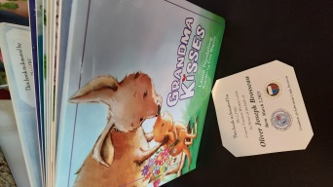
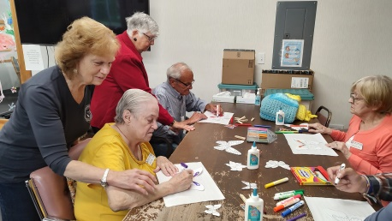
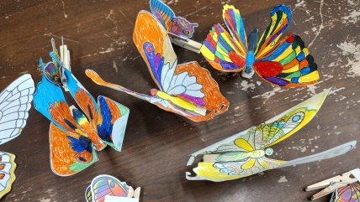
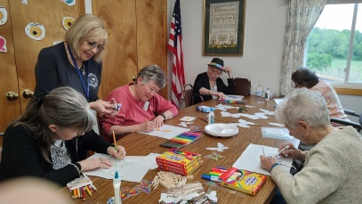
The spring tea fundraiser for local scholarships and charities from the GFWC Greater Taunton Woman's Club 'LET IT TEA', was held on Sunday, May 21, 2023, from 1:00pm to 3:00pm at St. Nicholas of Myra Parish Center, 499 Spring Street, North Dighton, MA. Tickets sold for $20, $10 for members totaling a profit of $2,240.33; $1330.33 in ticket sales after expenses and $910 in raffle money. The Tea menu gave a nod to the Beatles with entertainment included, basket raffles and door prizes. Preparation for the Tea began on Thursday May 18th and continued every day through Sunday the 21st. If you signed up to help you were called to be reminded a few days before the event. Once members cleaned off the tables they proceeded to arrange and set the tables. Thursday records were hung during the day. Friday morning at 10:00AM bags were filled, and the decorating of the backdrop screens was completed. Friday the sandwich crew made and wrapped sandwiches and refrigerated them. Saturday arrival was at 7:00PM Members set up tea pots, china cups and saucers, sugar and creamers were unwrapped rinsed and dried; electric pots were filled with water, and tables set. Sunday at 11:00AM sandwiches were placed into the bags. Members wore their club shirt and given one our new red club aprons to wear. Juniors served tea for 10 to 12 tables, which means at least one member per table seeing that tea pots were kept full and the water hot at all times. A singer came and a photo spot for guests to take advantage was set up. The raffle basket crew had everything under control and set up those tables on Saturday night as well. The doors opened and seating began at 1:00PM. Denise Wheeler collected tickets and people went to their assigned tables. Once there, a junior member brought over a pot of tea. Plates of dessert items were on each table, ten to a table. One of each sweet was placed at a table while all other food items were in their bags. Our spring fundraiser tea was a great success. The comments were positive and all who attended had a wonderful time. Our guests were generous as usual with the raffle ticket sales. In spite of any glitches it was a very fun afternoon with the Beatles! Robin Gendron delivered Teacher Appreciation Baskets to Bristol Plymouth Technical School teachers. Eight members attended the GFWC Annual Conference on May 5th to the 6th in Natick. Our club donated 19 pairs of sneakers. We won overall awards for Arts & Culture, Education & Libraries, Communication/PR, Legislation & Public Policy and WHRC and Special Recognition for Signature Program: Domestic Violence, and Health and Wellness. Once again we won for Overall Programs & Activities: The Big Bowl. Many thanks to all the Committee Chairmen for writing such clear detailed and inspiring reports and to Nancy Martin and especially Nancy Clark for conforming and organizing them to be reported. Our June Social will take place at Cindy Brogan’s Residence, June 12th, from 5:30pm-8pm. Go to the backyard, enjoy the pool and bring a dish to share. Kelly, Cindy’s daughter has volunteered to demonstrate and assist members who wish to make signs. The cost of the craft is $10 and wil be paid for by the club. On Saturday, May 20th at 9:00AM members Robin Gendron and Ana Kearnan placed flags at Mayflower Cemetery to honor Veterans for Memorial Day. As you know, our fellow junior, honorary member Susan Carlson, had been undergoing chemo for pancreatic cancer for quite some time. We just learned that she had been under hospice care and on Sunday night her daughter Lisa posted that she had passed away on Friday the 19th. Susan has been a member of our club for over thirty years. Susan has two daughters, Lisa and Lori, and four grandchildren, Thomas, Emma, Jane and Astrid. Cards of condolence can be sent to Dana Carlson 1038 Villa Drive Lebanon , PA 17042. There won't be a service for Susan Carlson in PA but her family requested that donations be made to Johns Hopkins University, Sol Goldman Center for Pancreatic Cancer research, 600 No. Wolfe Street, Carnegie 417, Baltimore, Maryland 21287; in her name. The club is making a $100 donation in her name to this charity. Nancy Brown has a Little Free Library at the corner of her property and the registration number is #135518. Members were invited to donate a book during Little Free Library Week and to check out the mobile app. There are several Little Free Libraries in our area. Thank you to all those members that did so. While Emily Weiland was volunteering at the Matthew Mission Food Pantry, a young man came up to her excited about one of the donations one of our members made - an extra-large package of oatmeal packets. He said "this will be my breakfast every day before work for two whole weeks!" Thanks to all our members who bring sugar and other food items to our meetings. It is very much appreciated, it really does help people. During the May Business Meeting members brought 12 lbs. of food including sugar and oatmeal for the Food Pantry. Emily communicated the need for food for the summer, stating the shelves are empty, so if you can spare any can goods or boxed food bring it to the June social for the food pantry. The Riverhouse Restaurant is sponsoring a fundraiser dinner for the Matthew Mission Food Pantry on June 20th at 7:00PM the donation is $100; if you’re interested in going contact member Emily Weiland. Thank you all for donating for May to rent relief, a total of $85 was collected. Brian pulled the winning name once again and the lucky lady is Nancy Clark. Cindy Leonard will deliver her gift, and Nancy Clark will provide the gift for September. Unfortunately we still pay a monthly fee for our storage facility, and though we can afford it better than in the past it's still a nice idea to continue to chip in to safeguard our archives and club paraphernalia. We will take a break for the summer months, but I do hope that in September you may consider donating. Ana Kearnan delivered to True Diversity 14 packages of sanitary napkins/tampons, antiperspirant, toothpastes, toothbrushes, mouthwashes, and tissues. The Scholarship Committee has completed scoring all 23 applications and the 7 recipients of the scholarships have been picked by highest score for each high school in the area along with one college student. The winners will be announced at the June Social and then be notified to attend the August Friendsgiving to receive their scholarship along with representatives from the Boys Club, Girls Club and YMCA. Emily Weiland has followed through with our $1000 donation to the Downtown Taunton Foundation and acquired knowledge how we as a non-profit can apply for a $500 rebate from the state for our contribution. Thank-you Emily. Nancy Clark is following through with the Brick purchase in GFWC MA Headquarters in Thelma’s name. Continuing with the BOOK-A-Baby Program, two of our members have had grandchildren: Linda Brosseau, a grandson Oliver Joseph Brosseau and Fran Perry a granddaughter, Jillian Clark. A book for each child will be donated to a library of their parents’ choice in their names. Thank-you Nancy Brown for buying, making and placing the book plates on the books and delivering them. The books are “Grandma Kisses” and “Llama Llama Red Pajama”. On Thursday May 25th from 10:30 to 11:30 three members: Nancy Brown, Grace Doel and Joyce Clark assisted ten seniors at the Prime Time Senior Center in Dighton with the making of a “Butterfly” craft. This entailed printing and cutting both large and small butterflies, clothespins, and the gluing and decorating of two butterflies each. All the supplies were donated or from our storage. The seniors enjoyed themselves so much they asked if we could help them paint and decorate rocks in the fall. The planning of our Friendsgiving on August 6th at the PACC, 175 School Street, Taunton from noon to 3:00PM is in the planning. It will be a catered event where we want to make sure our donors and event attendees are thanked and learn more about what our club is about. I hope you will be able to attend along with everyone you want to thank. Please email their names and addresses to me as soon as possible!
COMMITTEES:
ADVOCATES FOR CHILDREN–Robin Gendron – Presidents’ Project – No Report
ARTS AND CULTURE–Edith Edlund – No Report
CIVIC ENGAGEMENT AND OUTREACH –Cindy Brogan – Tuesday nights members needed to work the food booth at the Little League Field.
COMMUNICATIONS AND PUBLIC RELATIONS– Judy Floor –If you run an event please forward an article to Judy.
DOMESTIC VIOLENCE AND SEXUAL ASSAULT –
AWARENESS AND PREVENTION: - Emily Weiland – No Report
EDUCATION AND LIBRARIES – Nancy Martin –I know there have been some new grandchildren born, please notify me so we can award our Book-A-Baby Program.
ENVIRONMENT – Denise Wheeler – She is in need of newspapers, Styrofoam trays meats are wrapped, grocery plastic and cloth bags, shoe boxes, old batteries, old crayons, cereal and granola bar boxes flattened, shoes, clothes, broken jewelry, watches, yarn, fabric, ribbon, cardboard form notepads, eye/reading glasses, baskets, front of greeting cards, soda/beer can tabs, old markers, egg cartons for stem projects. Denise has paper lists of items for recycling that our club collects: just ask her for a copy; it is also on our club website.
FUNDRAISING AND DEVELOPMENT – Diane Huling – No Report
HEALTH AND WELLNESS – Ana Kearnan – Use suntan lotion when venturing outside and hats!
LEADERSHIP – Nancy Martin –Think about joining one of the committees by emailing the chairman with your interest, or chairing the committee for the Holiday Breakfast.
LEGISLATION/ PUBLIC POLICY – Nancy Clark – If you haven’t done it yet sign up for Legislative Action Center. If you need help doing so contact Nancy Clark.
MEMBERSHIP – Joyce Clark –A copy of the yearbook is on our website. Nancy Clark keeps it updated. Joyce has purchased pens with our new club name on them for both old and new members.
WOMENS HISTORY AND RESOURCE CENTER– Nancy Brown - Well I'm excited to read the interesting tidbits that you have gathered about our juniors. So far I have only received 9 replies.
Every member was handed instructions with a postcard attached, which had a club member's name on it. I randomly distributed them at the April business meeting, and I mailed the remainder to those who weren't in attendance. You were to return the postcards to me at the May business meeting so that I could prepare them for the June Social. Every member was given a name.
Please find your postcard and call your person. Ask them if they would share a fact about themselves that no one knows. Only ONE fact is required. EXAMPLE: This junior was in the play Macbeth in high school. Who is she?
OR, This junior played the violin in concerts when she was in her twenties. Who is she?
We also may not know that one of our members has 12 grandkids, or a black belt in karate.
JUST ASK. Very simple. You can write the info on your card and mail it to me, or call me on the phone and tell me and I will write it down.
You could also text it to me at 774 2181456. Do not send it in a reply email to me. I really would like to hear from more members. ( I did hand out 30 names.) It will be fun to hear the different things that our members use to do, or do now, that we don't know about. If, at the social, you can match the fact with the person, you will be given a
surprise. This is all for fun so no need to make it a chore. Pick up the phone, say hi, and just chat.

Member Summer Birthdays
Nancy Martin Joan Stevens Joanna Alden Mary Barrett Cheryl Carlos

What’s Happening Within our Club?

June Social Cindy Brogans House: 503 Dighton Ave, Taunton, June 12h 5:30PM to 8:00PM

Friendsgiving August 6th at the PACC, 175 School Street, Taunton from noon to 3:00PM

Next Executive Board Meeting is August 28th at 6:00pm at BP

Next Business Meeting is September 11th at BP at 7:00pm

New England Region Conference in Connecticut weekend of September 29th

Soup Sampler October 21st at Baptist Church downtown Taunton

Bingo for the Food Pantry, November 26th at the VFW Hall 82 Ingell Street, Taunton

Holiday Themed pancake Breakfast December 9th

What to Bring to the June Social

Appetizers

Canned goods or boxed food for the Food Pantry

Feminine Products for True Diversity

Yourself!
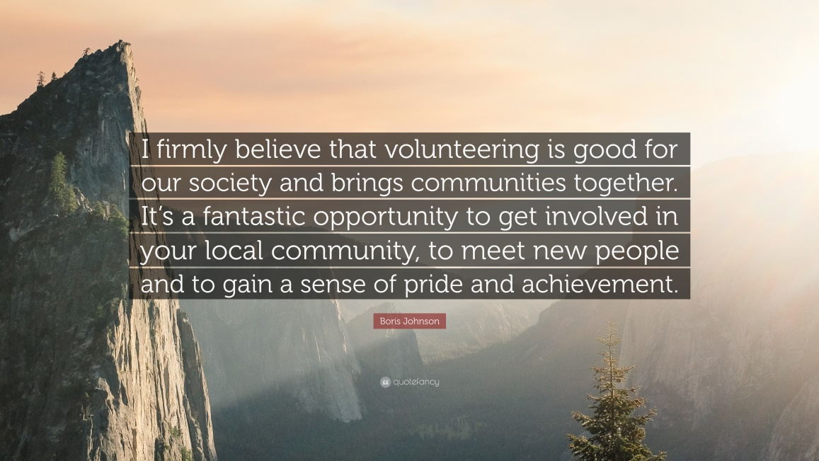

Enjoy the summer!

